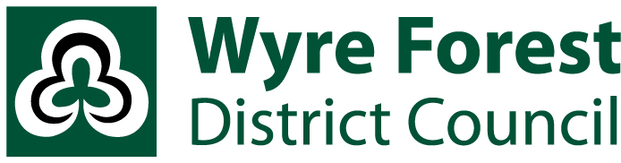

**AUDIT OF ACCOUNTS YEAR ENDED 31ST MARCH 2023**

**NOTICE OF CONCLUSION OF AUDIT**

**ACCOUNTS AND AUDIT (ENGLAND) REGULATIONS 2015**

**LOCAL AUDIT AND ACCOUNTABILITY ACT 2014**

Notice is hereby given under Regulation 16 (1) of the Accounts and Audit Regulations 2015 that the external auditor has concluded their audit of the statement of accounts for the year ended 31st March 2023, which has been published.

On reasonable notice a local government elector for any area to which the accounts relate may inspect and receive copies of the following documents:

1. the statement of accounts prepared by the authority,
2. the local auditor’s certificate that the audit of the authority’s accounts including that statement has been completed,
3. the auditor’s opinion on the statement of accounts.

The documents referred to above will be made available for inspection by contacting 01562 732928 to make a request. A copy of the Statement of Accounts 2022-23 is also available to download at [www.wyreforestdc.gov.uk](http://www.wyreforestdc.gov.uk).

Date: 23/04/2024

Helen Ogram, CPFA,

Head of Resources & S151 Officer,

Wyre Forest House,

Finepoint Way,

Kidderminster,

Worcestershire,

DY11 7WF